Using Stopmi Tool

Editor: Mani Jorda Garcia

INTRODUCTION

Welcome to Stopmi, a new way to create graphical user interfaces using the Java programming language.
This guide describes several steps required to use the stopmi framework: how to install the stopmi library in your development tool and how to use those libraries.
Please read this documentation which contains a quick-start information to take off with the stopmi tool as well as answers to the most frequently asked questions.
For further information on the documentation available please consult the Stopmi web page at:

http://mjorda.web.cern.ch/mjorda/stopmi/

- INCLUDING STOPMI LIBRARIES IN JBUILDER.

STEP ONE: MAPPING ONE OF YOUR DISKS IN WINDOWS EXPLORER.

The stopmi libraries are installed on a Unix server and can be accessed from a MS WINDOWS environment. All you need is to map one of your disks on \\pcslux10\production (To map in Windows explorer: Tools/MapNetwork Drive,and then fill in the path specified choosing a disk to map).

STEP TWO: ADDING STOPMI LIBRARY TO JBUILDER.

To add a new library in Jbuilder you need to follow these steps:
- Once you have Jbuilder opened, press on the “Project” menu item in the menu bar.
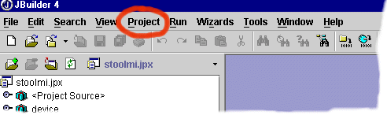

Fig. 1.1

- Select “Default Project Properties” from the pull down menu.

- A dialog box appears with different tabs on the top. Stay on the “Paths” tab that is selected by default, press on “Required libraries” which is another tab located in the middle of the dialog box.

- Press the “Add” button.
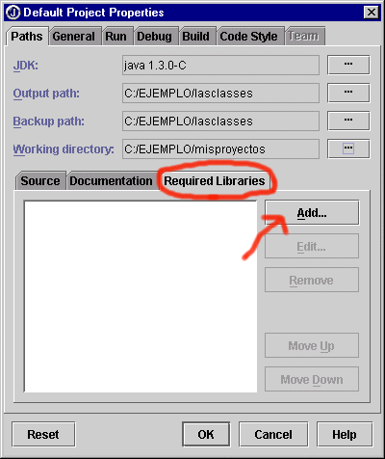

Fig.1.2

- A dialog box appears where you can include those libraries you want the tool to read when compiling your files. First of all you need to create a library from stopmi files.

- Press “New”, a button you can find on the bottom of the dialog box.

- The following window appears:
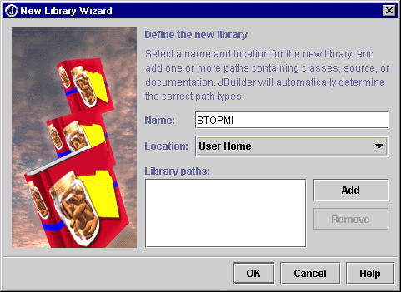

Fill in the first field specifying the name of the library, e.g. “Stopmi” .
Leave the location of the library option as it is set by default (“User Home”).
Then press “Add” to specify the path to the stopmi files.

Fig.1.3

- You will see another window that lets you manage your files. On the disk you have mapped with the stopmi files, select the “stopmiLIB.jar” file which is under the stopmi directory and press OK.

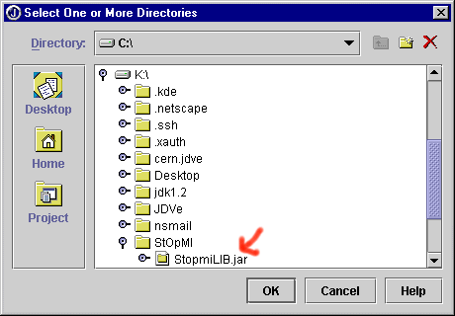

Fig 1.4

Press “ADD” again and select the StopmiExternalLIB.jar to include it in the Stopmi library.

- Press OK again and you will see a window where the newly created library has been included (“Stopmi”). Select it, press ok and you will see that your library has been added to the “Required libraries” area.
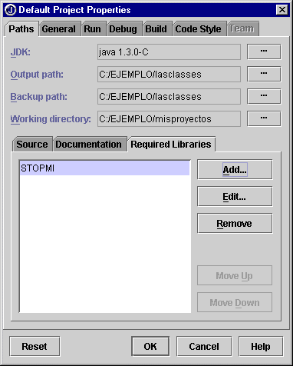

Fig. 1.5

- ADDING STOPMI BEANS TO JBUILDER PALETTE.

Note: this action can be performed if you have included the Stopmi library in your development tool, as described in part1.

To include the stopmi beans on your palette, follow these steps:

- Select the “Tools” option from the menu bar in Jbuilder and select “Configure palette” from the pulling submenu.
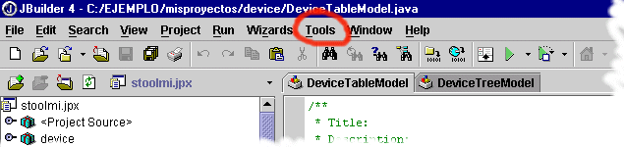

Fig. 2.1

- A palette properties window appears with two tabs at the top: “Pages” and “Add Components”. “Pages” refers to the way that beans are organized on the palette.

- Create a new page to include your stopmi beans. With the “Pages” tab selected press “Add” button. Write the name of the new page you are creating.

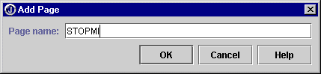

Fig. 2.2

- Once you have created a new page, you will see that it appears on the list of existing pages. Select the page created and change the top tab to “Add components”.

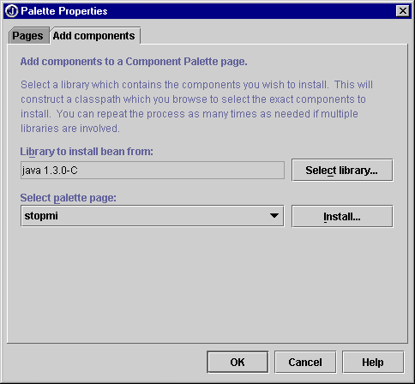
Fig. 2.3

- Press the “Select library” button. Then select the Stopmi library you created with the first part of this guide.

- Press OK to get back to the “Palette properties” window. Press the “Install” button and look for the Cern folder in the tree. Open the “Stopmi / Beans” folder and select all the OPBeans you find inside, except by the OPLabTypes and BeanInfo files (to select more than one bean at a time, hold the “CTRL” button when selecting the OPBeans).

- Press ok and you will receive a message confirming that your beans have been added to your palette.

If you have followed the steps correctly, the OPBeans should now appear on your palette.

3. STOPMI APPLICATIONS

An application consists of:

- Panels
- Controllers
- A Frame

Panels are the view of your application, containers with all your beans (buttons, textfields,…)
Controllers define callbacks for the beans on the Panels.
The Frame associates Panels and Controllers.

You can have as many Panels and Controllers as you desire, and the number of Panels do not have to be the same as the Controllers, e.g. three Panels can be “controlled” by only one Controller.

Panel1. java
Panel2. java
Controller1.java
MainFrame.java

Panel1.java Controller1.java
Panel2.java Controller1.java

Steps to follow to create an application:
Create the Panels you need for your application
1
Define the Controller or Controllers you may need.
2
Iinclude the Controller and Panels created in the Frame.
3

- WORKING WITH STOPMI

Stopmi provides a “Stopmi wizard” to automatically generate the files you need for an application. You only have to run the wizard program located in Stopmi folder (from \\pcslux10\production mapped file) and fill in the fields required. This program will create java files according to the description presented previously: a frame, a panel and two controllers (there’s one for the menu, these have an independent controller file). These files include the basic methods you need to run an application. You can add more panels and controllers if you need them.
To import these generated files into Jbuilder, go to “File” option in the menu bar and then click on “Open Project”. You will see a window with a tree explorer. Look for the path you specified in the “stopmi wizard” and select the “.jpr “ file that is been generated. Press the “ok” button and the files created by the wizard will be now imported by the tool.

  - CREATING A PANEL.

- Design by hand your interface.
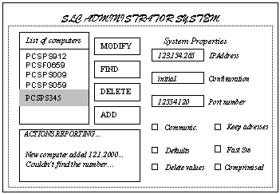

Fig. 3.1 Example of an interface

- The interface you have created is a Panel in Java, and the elements you have placed in your interface like buttons, labels, textfields,..etc. are called “beans”. In Appendix 3 you can find all the beans that Stopmi provides.

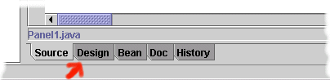
3. In Jbuilder open the file with the sufix “-mainPanel” that is been generated by the wizard. Your Panel appears now opened in Jbuilder as source code. Click the Design tab at the bottom to open the designer.
Fig. 3.2

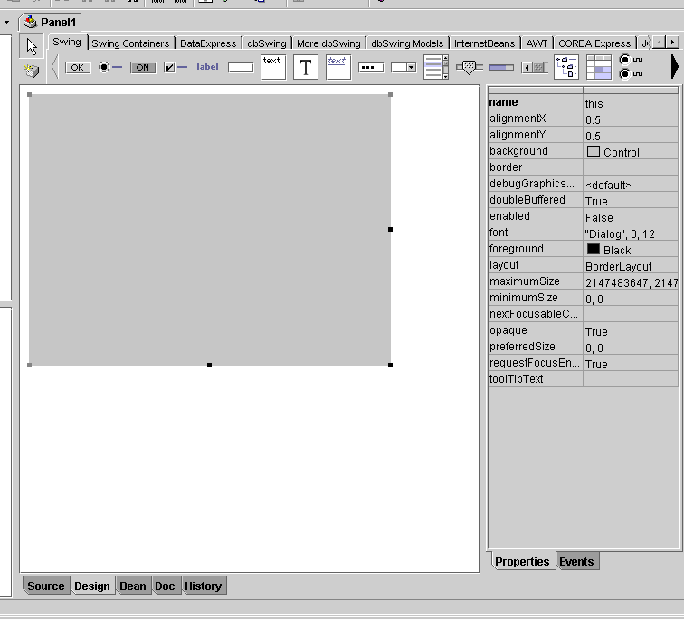
This is what you see on the designer. The central square is your panel, you can enlarge it with your mouse clicking and dragging the point in the corner.
Panel
Click the arrows to find the stopmi beans you have included in Part 1
Properties corresponding to the object selected on the left, panel in this case.

Fig. 3.3 Designer

3.1 The OPPanel you are working with has the ”layout” property set to “XYLayout”. This is a trick that will let you place the components wherever and with whatever size you like. After placing all the components you will change the layout again to a simpler one, so your panel description will not be so heavy and the components will adapt to a size change. For this layout conversion to be effective you have to place your beans in a way that the tool can convert their position to a defined layout. You can get this defining nested panels. (apendix 3 identifies the most common layouts you can use).

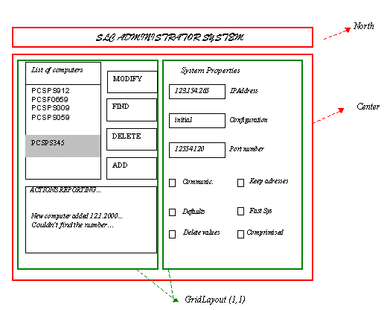
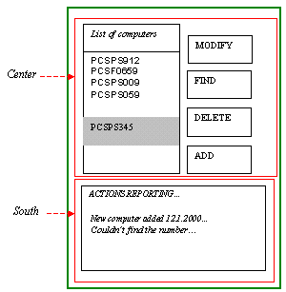
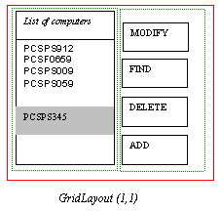
3.2 Identify the nested layouts your interface could be composed of. With the example, we could say:

Fig. 3.5

3.6 Place the OPPanels: Select the Stopmi beans page (1), click on OPPanel bean (2) and then click to place it on the main area (3).

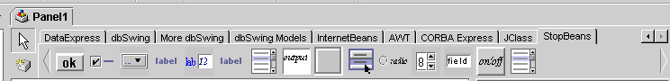
(1)

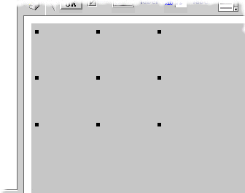
OPPanel
(2)
NOTE: On the properties panel on the right you can change the OPBorder property, so you can see the panel you have placed clearer.
(3)

Fig. 3.6

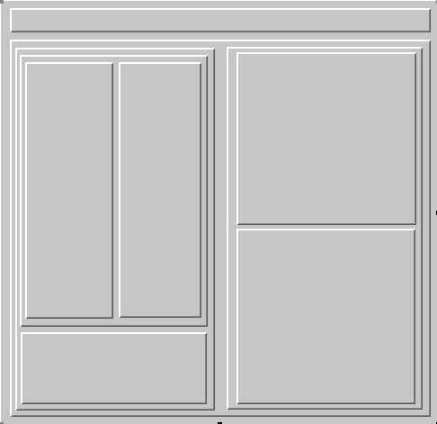
3.7Adding successive OPPanels and resizing them you should get to this point:

Fig 3.7. Nested Layouts.
3.8 Start placing your OPBeans from the top layer to the bottom one. Follow the same 3 steps as before but selecting the corresponding beans.
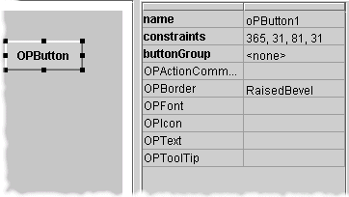
Use the Properties Panel on the right to change labels, borders, fonts…
Consult the appendix 4 for the meaning of the different properties.

Fig. 3.8

3.9 Place the first four buttons and change its properties.
Save time!: By pressing the “ctrl” button while selecting components, you can change properties for all the components selected at the same time.
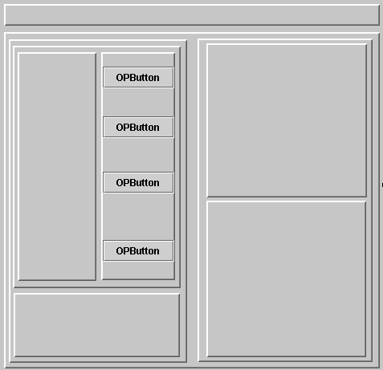
Fig. 3.9

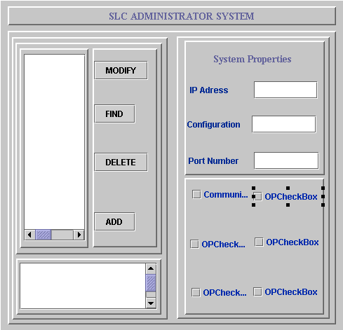
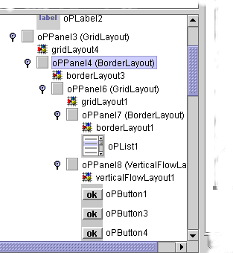
3.10 Continue placing components and remember that you can use the tree on your left to select components, copy and paste, delete, etc and see how your panels are organized.

Fig. 3.10

3.11 Once you have placed all the components it is time to change the panel layouts. Remember that you have worked with XYLayout and if you do not change this layout your panel definition will be long, heavy and will not resize when you run your application.

3.12 Select one of the top panels, e.g. the one containing the four buttons and change the Layout property to VerticalFlowLayout.
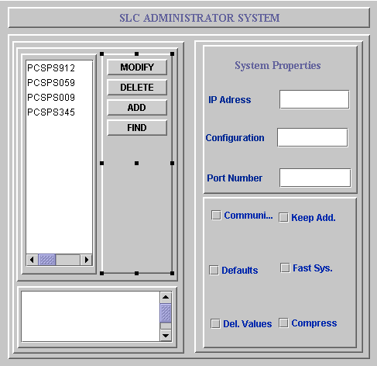
Fig. 3.11. Changing the layout

3.13 Continue converting the layouts that you have defined at the beginning of your design. If you have only one component over a panel, change to BorderLayout (you use this panel below the component because this is your first design, in the future you will not need it). When changing to GridLayout, you can specify number of columns and rows clicking on “Gridlayout” on the tree on your left. Figure 3.12 shows more layout changes and in figure 3.13 the borders of OPPanels have been modified too.

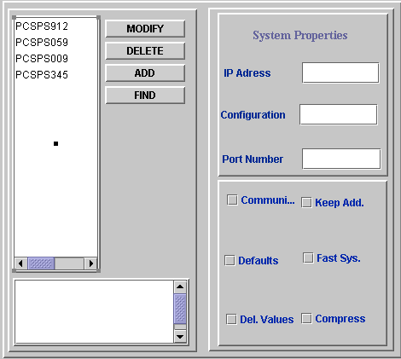

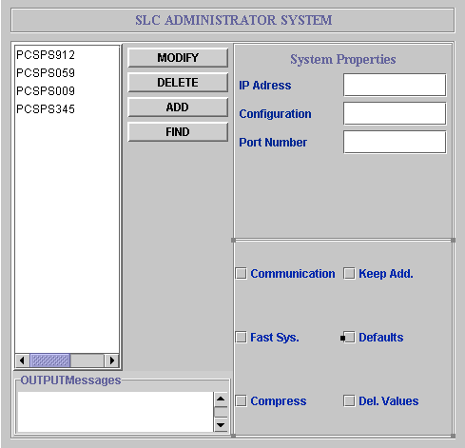

Fig 3.12 and Fig 3.13

3.14 Performing the last change:

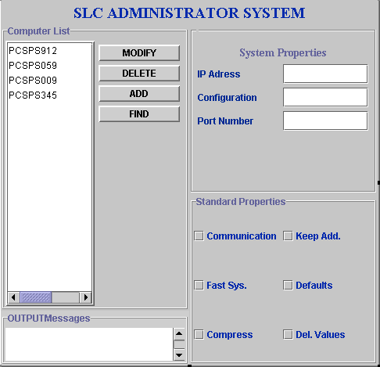

OPBEANS

Fig 3.14.

3.2 DEFINING THE CONTROLLER.

The controller is a Java file that defines the actions performed by your application. It extends from OPController, so you will have all the facilities that this class provides.
If you implement some Java Listeners you can trap the action events of your application and define the actions to be executed:
public class Controller extends OPController implements ActionListener, ListSelectionListener{

By default the Controller generated by the wizard includes an “ActionListener” interface and its corresponding method “ActionPerformed”. Add the Listeners you may need to define your controller.

OPController provides a method to get the reference of the panel you want to define the callbacks for:

- getOPPanel (Object o)
- getOPPanel (Class toSearchFor)

If you have the reference of a panel you can get the reference to all the components placed on that panel:
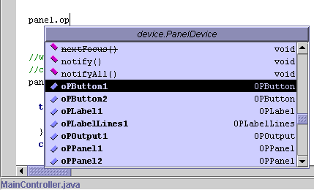

You can also access the properties defined for those components:
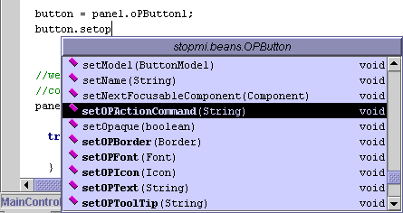

3.3 EXAMPLE

TestPanel

import cern.stopmi.beans.*;
import com.borland.jbcl.layout.*;
import java.awt.*;
import javax.swing.*;
import java.awt.event.*;

public class TestPanel1 extends OPPanel {
OPList myList = new OPList();
LayoutManager layoutManager1 = new VerticalFlowLayout();
OPLabel myLabel1 = new OPLabel();
OPButton myButton = new OPButton();
OPLabel myLabel2 = new OPLabel();
OPLabel myLabel3 = new OPLabel();
OPLabel myLabel4 = new OPLabel();
OPButtonGroup myButtonGroup = new OPButtonGroup();
OPCheckBox myCheckBox = new OPCheckBox();
OPComboBox myComboBox = new OPComboBox();
OPLabelAndField myLabelAndField = new OPLabelAndField();
OPLabelLines myLabelLines = new OPLabelLines();
OPOutput myOutput = new OPOutput();
OPPopupMenu myPopupMenu = new OPPopupMenu();
OPButton myPopupButton = new OPButton();
OPRadioButton myRadioButton1 = new OPRadioButton();
OPRadioButton myRadioButton2 = new OPRadioButton();
OPTextField myTextField = new OPTextField();
OPToggleButton myToggleButton = new OPToggleButton();
JMenuItem myMenuItem1 = new JMenuItem();
JMenuItem myMenuItem2 = new JMenuItem();
JMenuItem myMenuItem3 = new JMenuItem();
OPPanel embeddedOPPanel = new OPPanel();
JButton myButtonInAnOPPanel = new JButton();
OPCheckBox oPCheckBox1 = new OPCheckBox();

public TestPanel1() {
try {
jbInit();
}
catch(Exception e) {
e.printStackTrace();
}
}

private void jbInit() throws Exception {
myList.setOPBorder(BorderFactory.createEtchedBorder());
myList.setOPItems(new String[] {"Item 1", "Item 2", "Item 3", "Item 4", "Item 5", "Item 6", "Item 7"});
myLabel1.setOPLabTypes("normal");
myLabel1.setOPText("Normal OPLabel");
myLabel2.setOPText("Italic OPLabel");
myLabel2.setOPLabTypes("italic");
myLabel3.setOPText("Next to bean OPLabel");
myLabel3.setOPLabTypes("nextToBean");
myLabel4.setOPText("Title OPLabel");
myLabel4.setOPLabTypes("Title");
this.setOPLayout(layoutManager1);
myComboBox.setOPItems(new String[] {"Item 1", "Item 2", "Item 3", "Item 4", "Item 5", "Item 6", "Item 7"});
myLabelLines.setOPLabTypes("normal");
myLabelLines.setOPTextLine_1("OPLabelLines... Line 1");
myLabelLines.setOPTextLine_2("OPLabelLines... Line 2");
myLabelLines.setOPTextLine_3("OPLabelLines... Line 3");
myOutput.setOPText("OPOutput is used to output text");
myPopupButton.setOPText("Click here to get an OPPopupMenu");
myRadioButton1.setOPText("OPRadioBut1");
myRadioButton2.setOPText("OPRadioBut2");
myTextField.setOPValue(1.0);
myToggleButton.setOPTextdisable("OPToggleButton is disabled");
myToggleButton.setOPTextenable("OPToggleButton is enabled");
myMenuItem1.setText("Option 1");
myMenuItem2.setText("Option 2");
myMenuItem3.setText("Option 3");
myButtonInAnOPPanel.setText("jButton1");
myPopupMenu.setInvoker(myPopupButton);
this.add(myList);
this.add(myLabel1, new XYConstraints(87, 153, -1, -1));
this.add(myLabel2, new XYConstraints(0, 0, 390, -1));
this.add(myLabel3, new XYConstraints(0, 0, 390, -1));
this.add(myLabel4, new XYConstraints(0, 0, 390, -1));
this.add(myButton, new XYConstraints(6, 238, 390, -1));
this.add(myCheckBox, new XYConstraints(111, 337, -1, -1));
this.add(myComboBox, new XYConstraints(196, 433, -1, -1));
this.add(myLabelAndField, new XYConstraints(141, 428, -1, -1));
this.add(myLabelLines, new XYConstraints(5, 394, 728, -1));
this.add(myOutput, new XYConstraints(131, 497, -1, -1));
this.add(myPopupButton, new XYConstraints(241, 567, -1, -1));
this.add(myRadioButton1, new XYConstraints(205, 589, -1, -1));
this.add(myRadioButton2, new XYConstraints(149, 609, -1, -1));
this.add(myTextField, new XYConstraints(96, 591, -1, -1));
this.add(myToggleButton, new XYConstraints(218, 608, -1, -1));
this.add(embeddedOPPanel, null);
this.add(oPCheckBox1, null);
embeddedOPPanel.add(myButtonInAnOPPanel, new XYConstraints(46, 26, -1, -1));
myButtonGroup.add(myRadioButton1);
myButtonGroup.add(myRadioButton2);
myPopupMenu.add(myMenuItem1);
myPopupMenu.add(myMenuItem2);
myPopupMenu.add(myMenuItem3);
}
}

TestController

import cern.stopmi.OPGeneric.OPController;
import cern.stopmi.beans.OPPanel;
import javax.swing.event.*;
import javax.swing.*;
import java.awt.*;
import java.awt.event.*;
import cern.stopmi.OPGeneric.OPStatus;
import java.beans.PropertyChangeListener;
import java.beans.PropertyChangeEvent;

public class TestController extends OPController implements ActionListener, ListSelectionListener, CaretListener, PropertyChangeListener{

public void propertyChange(PropertyChangeEvent evt){
System.out.println("Property changed event ("+evt+") on "+evt.getPropertyName());
}

public void actionPerformed (ActionEvent e){
// This is the calling panel (could be null)
OPPanel caller = getOPPanel(e.getSource());

// method 1. The component triggering the callback is a DIRECT child of TestPanel1
// Note that this won't work for 'inner' panels if the controller has had its
// registerSubPanels set to true...
if(caller instanceof TestPanel1){
System.out.println("Caller was TestPanel1");
// cast to make it easier...
TestPanel1 p = (TestPanel1)caller;
// match against specific component here...
if(e.getSource() == p.myPopupButton)
p.myPopupMenu.show((Component)e.getSource(),0,0);
// the next line should prove that with registerSubPanels set to true, we
// can access components in subpanels too...
else if(e.getSource() == p.myButtonInAnOPPanel)
OPStatus.getInstanceFor((JComponent)e.getSource()).message("You clicked on an 'inner' button");
}

// Method 2. For components which are not a decsendant of this panel, such
// as a JMenuItem, you have to be a little more clever
// Get reference to TestPanel1 directly (as the caller was not TestPanel1
// but the container for the menuitem!)
TestPanel1 tp1 = (TestPanel1)(getOPPanel(TestPanel1.class));
if(e.getSource() instanceof JMenuItem){
JMenuItem mi = (JMenuItem)e.getSource();
// you can find WHICH menu it came from like this...
if(mi.getParent() == tp1.myPopupMenu)
// and of course which item it is
if(mi == tp1.myMenuItem1)
// note that here, we can only get a reference from OPStatus from 'shared'
// as our component is not contained in a frame with an OPStatus really...
OPStatus.getSharedInstance().message("You selected menu item 1");
}

System.out.println("Action performed");
}
public void valueChanged(ListSelectionEvent e){
System.out.println("Value changed"+e);
}
public void caretUpdate(CaretEvent e){
System.out.println("Caret update");
}
}

TestBench

import cern.stopmi.beans.*;
import java.awt.*;
import javax.swing.*;
import com.borland.jbcl.layout.*;
import cern.stopmi.OPGeneric.*;
import java.lang.reflect.*;

public class TestBench extends OPSkel {
TestPanel1 testPanel11 = new TestPanel1();
TestController testController1 = new TestController();
JMenuBar unusedMenuBar = new JMenuBar();
JMenu myMenu = new JMenu();
JMenuItem myMenuItem1 = new JMenuItem();
JMenuItem myMenuItem2 = new JMenuItem();
TestMenuController myMenuController = new TestMenuController();
JMenu myMenu2 = new JMenu();
JMenuItem menuConnect = new JMenuItem();

public TestBench() {
try {
OPLookAndFeel.setOPLookAndFeel();
jbInit();

OPController.setIsDebug(true);
// add our menu bar and control it
getJMenuBar().add(myMenu);
getJMenuBar().add(myMenu2);
myMenuController.addListenersNeeded(myMenu);
myMenuController.addListenersNeeded(myMenu2);
myMenuController.addObjectReference(this);

//set up the main controller
testController1.addListenersNeeded(testPanel11);
// need to add popup menus seperately
testController1.addListenersNeeded(testPanel11.myPopupMenu);

// fire any old property
testPanel11.myButton.firePropertyChange("OWT",'a','b');

}catch(Exception e) {
e.printStackTrace();
}
}

public static void main(String[] args) {
TestBench testBench1 = new TestBench();
testBench1.setVisible(true);
}

private void jbInit() throws Exception {
myMenu.setText("Controller");
myMenuItem1.setText("Select 1");
myMenuItem2.setText("Select 2");
myMenu2.setText("More Commands");
menuConnect.setText("Connect to equipment");
this.getContentPane().add(testPanel11, BorderLayout.CENTER);
unusedMenuBar.add(myMenu);
unusedMenuBar.add(myMenu2);
myMenu.add(myMenuItem1);
myMenu.add(myMenuItem2);
myMenu2.add(menuConnect);
}
}

TestMenuController

import cern.stopmi.OPGeneric.OPController;
import cern.stopmi.OPGeneric.*;
import javax.swing.event.*;
import javax.swing.*;
import java.awt.*;
import java.awt.event.*;

public class TestMenuController extends OPController implements ActionListener{

public void actionPerformed (ActionEvent e){
TestBench testBench = (TestBench)getObject(TestBench.class);

if(e.getSource() == testBench.myMenuItem1)
OPStatus.getInstanceFor(testBench).message("Menu action 1");
else if(e.getSource() == testBench.myMenuItem2)
OPStatus.getInstanceFor(testBench).message("Menu action 2");
else if(e.getSource() == testBench.menuConnect){
Thread t = new Thread(){
public void run(){
OPStatus.getSharedInstance().startActivity();
// hey - there is no equipment
try{sleep(5000);}catch(Exception ex){}
OPStatus.getSharedInstance().stopActivity();
OPStatus.getSharedInstance().message("Connected to equipment 8-)");
}
};
t.start();
}
else
OPStatus.getInstanceFor(testBench).message("Unknown menu action!!");
}

}

APPENDIX 1: ADDING MODELS TO YOUR COMPONENTS.

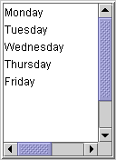
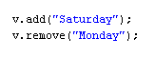
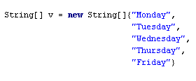
Models are classes that keep the data to be presented by the view and to be modified by the controller. The components that normally have a model associated are Lists, Tables and Trees.
VIEW
CONTROLLER
MODEL

Fig. 3.1

Models are created as separated classes and are associated to the corresponding view in the Frame definiton. Remember to register this model passing the reference to the Controller, so you can always access it and modify this model. Look at the following example; the Frame includes the model and the Controller uses it.

TestBench

import cern.stopmi.beans.*;
import java.awt.*;
import javax.swing.*;
import com.borland.jbcl.layout.*;
import cern.stopmi.OPGeneric.*;
import java.lang.reflect.*;

public class TestBench extends OPSkel {
TestPanel1 testPanel11 = new TestPanel1();
TestController testController1 = new TestController();
ListModel myModel = new ListModel();
JMenuBar unusedMenuBar = new JMenuBar();
JMenu myMenu = new JMenu();
JMenuItem myMenuItem1 = new JMenuItem();
JMenuItem myMenuItem2 = new JMenuItem();
TestMenuController myMenuController = new TestMenuController();
JMenu myMenu2 = new JMenu();
JMenuItem menuConnect = new JMenuItem();

public TestBench() {
try {
OPLookAndFeel.setOPLookAndFeel();
jbInit();

OPController.setIsDebug(true);
// add our menu bar and control it
getJMenuBar().add(myMenu);
getJMenuBar().add(myMenu2);
myMenuController.addListenersNeeded(myMenu);
myMenuController.addListenersNeeded(myMenu2);
myMenuController.addObjectReference(this);

//set up the main controller
testController1.addListenersNeeded(testPanel11);
testController1.addObjectReference(myModel);
// need to add popup menus seperately
testController1.addListenersNeeded(testPanel11.myPopupMenu);

//add the model to the view
testPanel11.oPList1.setModel(myModel);

// fire any old property
testPanel11.myButton.firePropertyChange("OWT",'a','b');

}catch(Exception e) {
e.printStackTrace();
}
}

public static void main(String[] args) {
TestBench testBench1 = new TestBench();
testBench1.setVisible(true);
}

private void jbInit() throws Exception {
myMenu.setText("Controller");
myMenuItem1.setText("Select 1");
myMenuItem2.setText("Select 2");
myMenu2.setText("More Commands");
menuConnect.setText("Connect to equipment");
this.getContentPane().add(testPanel11, BorderLayout.CENTER);
unusedMenuBar.add(myMenu);
unusedMenuBar.add(myMenu2);
myMenu.add(myMenuItem1);
myMenu.add(myMenuItem2);
myMenu2.add(menuConnect);
}
}

TestController

import cern.stopmi.OPGeneric.OPController;
import cern.stopmi.beans.OPPanel;
import javax.swing.event.*;
import javax.swing.*;
import java.awt.*;
import java.awt.event.*;
import cern.stopmi.OPGeneric.OPStatus;
import java.beans.PropertyChangeListener;
import java.beans.PropertyChangeEvent;

public class TestController extends OPController implements ActionListener, ListSelectionListener, CaretListener, PropertyChangeListener{

public void propertyChange(PropertyChangeEvent evt){
System.out.println("Property changed event ("+evt+") on "+evt.getPropertyName());
}

public void actionPerformed (ActionEvent e){
// This is the calling panel (could be null)
OPPanel caller = getOPPanel(e.getSource());

// method 1. The component triggering the callback is a DIRECT child of TestPanel1
// Note that this won't work for 'inner' panels if the controller has had its
// registerSubPanels set to true...
if(caller instanceof TestPanel1){
System.out.println("Caller was TestPanel1");
// cast to make it easier...
TestPanel1 p = (TestPanel1)caller;
// match against specific component here...
if(e.getSource() == p.myPopupButton)
p.myPopupMenu.show((Component)e.getSource(),0,0);
//we get the value from the textfield and add it to the listmodel
ListModel list = (ListModel)(getOPPanel(ListModel.class));
list.add(p.oPTextField1.getOPText());
// the next line should prove that with registerSubPanels set to true, we
// can access components in subpanels too...
else if(e.getSource() == p.myButtonInAnOPPanel)
OPStatus.getInstanceFor((JComponent)e.getSource()).message("You clicked on an 'inner' button");
}

}

APPENDIX 2: PROPERTY’S NAMES

Property name | Description | Value Types
OPColumns | Number of columns in text areas | int
OPItems | List of Strings | String
OPBorder | Definition of the drawing limits. | Etched, Line, Titled, LoweredBevel, Line RaisedBevel, null
OPFont | Text font | java.awt.Font
OPIcon | To include drawings on beans | Java.awt.imageicon
OPModel | Used in OPList to insert a Java List Model. | ListModel
OPText | Text on the bean. | String
OPToolTip | Helping information that comes up when dragging the mouse on a component. | String
OPSelectionMode | Mode of selection in Lists | Int (0,1,2)
OPRows | Number of rows in text areas | int
OPTextLine_x | Line of text for multi-line labels | String

APPENDIX 3

OPBEANS | PROPERTIES
OPLabel | OPIcon, OPBorder, OPText, OPLabTypes, OPToolTip.
OPButton | OPBorder, OPText, OPLabTypes, OPToolTip, OPIcon.
OPCheckBox | OPBorder, OPText, OPFont, OPToolTip
OPComboBox | OPBorder, OPText, OPFont, OPToolTip, Items
OPLabelAndField | OPBorder, OPText, OPToolTip, OPDataProperty.
OPLabelLines | OPBorder, OPLabTypes, OPToolTip, OPTextLine_1, OPTextLine_2, OPTextLine_3
OPList | OPItems,OPBorder, OPToolTip, OPModel, OPSelectionMode
OPOutput | OPColumns, OPBorder, OPtext, OPToolTip, OPRows
OPPanel | OPBorder, OPLayout, OPPreferredsize
OPRadioButton | OPBorder, OPText, OPToolTip.
OPSpinField | OPBorder, OPToolTip.
OPTextField | OPBorder, OPToolTip, OPFont.
OPToggleButton | OPBorder, OPText, OPLabTypes, OPToolTip, OPIcon.

APPENDIX 3: LAYOUTS

FlowLayout

This is the simplest of the AWT layout managers. Its layout strategy is:

- lay out as many components as will fit horizontally within a container
- start a new row of components if more components exist
- if all components can not fit, they are not shown.
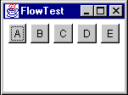
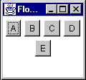
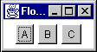
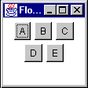

BorderLayout

BorderLayout is probably the most useful of the standard layout managers. It defines a layout scheme that maps its container into five logical sections:
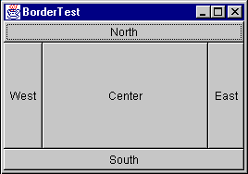
The first thing going through your mind should be "but I will never have a GUI that looks like that!" Moreover, you are probably correct. However, the secret is in mastering its nesting capabilities, and using two or three of the logical sections. (It's very rare that you'll actually use more than three of the positions in a container at once).

GridLayout

GridLayout lays out its components in a grid. Each component is given the same size and is positioned left-to-right, top-to-bottom. When specifying a GridLayout, there are two main parameters: rows and columns.

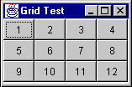

APPENDIX 4 : HOW TO CREATE A TABBEDPANE

If your application has information that you can not display in a panel, you can use tabbedPane Layout.
You define your panels as you would do for a multi Panel interface and then you include them in the Frame and create the tabbed pane:

LimPanel panel1 = new LimPanel( );
CalPanel panel2 = new CalPanel( );
TgrPanel panel3 = new TgrPanel( );
MoreInfo panel4 = new MoreInfo();

JTabbedPane jTabbedPane1 = new JTabbedPane();

In the constructor of the Frame…:

jTabbedPane1.addTab("Status", panel1);
jTabbedPane1.addTab("SetPosition", panel2);
jTabbedPane1.addTab("MoreInfo", panel3);
jTabbedPane1.addTab("More Info" ,panel4);

And finally remember to include the JtabbedPane in your Frame:

this.getContentPane().add(jTabbedPane1);

- HOW TO CREATE POPUPMENUS.

PopUpMenus are small windows that appear when you click the right button of your mouse on a component. You can create these menus when designing your panel with Jbuilder:

- Click on OPPopUpMenu on the palette and paste it anywhere on your panel.
- You will see that in the tree facility of Jbuilder the “Menu” folder is open and your Popupmenu has been added:
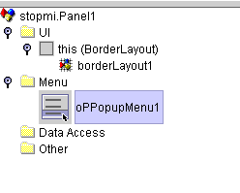

- Click twice on the new oPPopupMenu1 placed on the above mentioned tree.

- Your Panel is not shown now and a new visual designer appears. This is the designer used by Jbuilder to create PopupMenus.
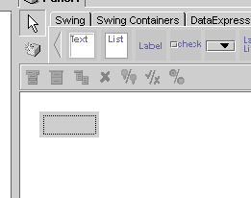

- Click twice on the small square to start creating your menu. You have a small palette to add new items, separators, submenus…
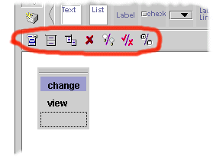

- Once you have finished creating your OPPopUpMenu, click on one of the OPBeans from the tree in Jbuilder tool to see your main panel again.
- The popupmenu you have just created is part of your Panel, so you can have a reference to it as to the other variables on the Panel.

